Advance Code Editing
Helps the developers in advance coding by providing tools and techniques to make their life a lot easier.
Template changing using Java Class
You can add you the name of the author of the program at the top also the date and some comments before the coding starts.
- You go to the tools templates.
- Find Java then choose Java Class and click Open editor.
- Now you can insert the author of the program and also the description, date and comment of the instructor.
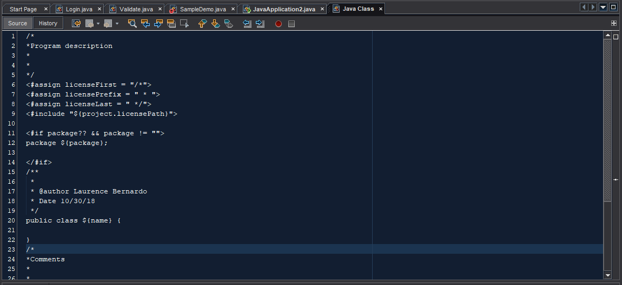
- Don’t forget to save, then open a new Java class.
Shortcuts Code from keyboard template.
There are a lot advantage using NetBeans IDE keyboards one of this is Keyboard Shortcuts.
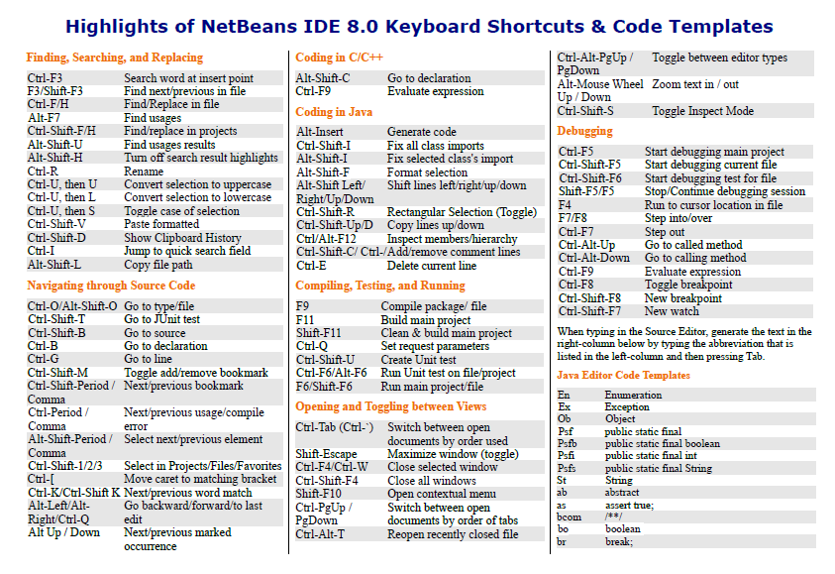
This Shortcut Keyboard is not available to other IDE’s.
Formatting Code in NetBeans
You can indent selected multiple lines of codes by pressing Tab or Alt+Shift+Right, and you can also reverse the indentation by pressing Shift+Tab or Alt+Shift+Left.
The editor toolbar has two buttons that can use for indenting and unindenting the selected multiple lines of codes.
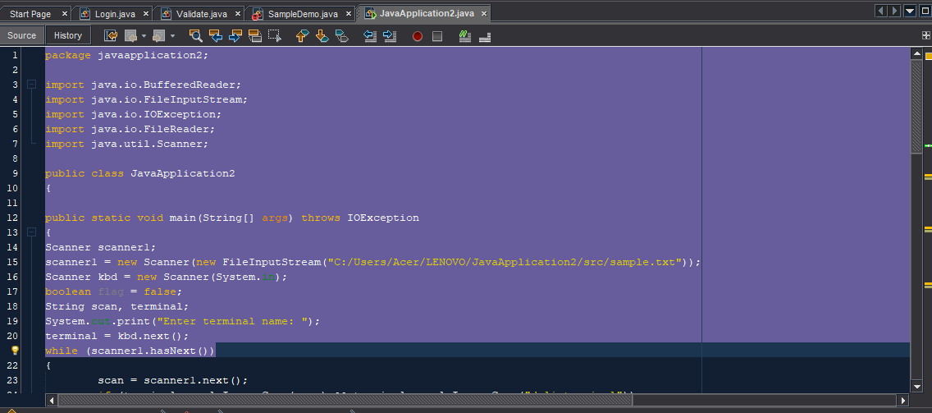

Changing Format Rules
For the file types that you created, you can adjust the files in the formatting settings, such as placement of curly braces, number of spaces per tab, and so on. To adjust formatting rules for your Java files:
- You go to the tools menu, find the options and click the editor button in the left panel.
- Click editor button.
- You can choose in the different categories.
- For my demo I will choose Tabs and Indents.
- Adjust the properties for the indention tab engine to your taste then click Ok to App.
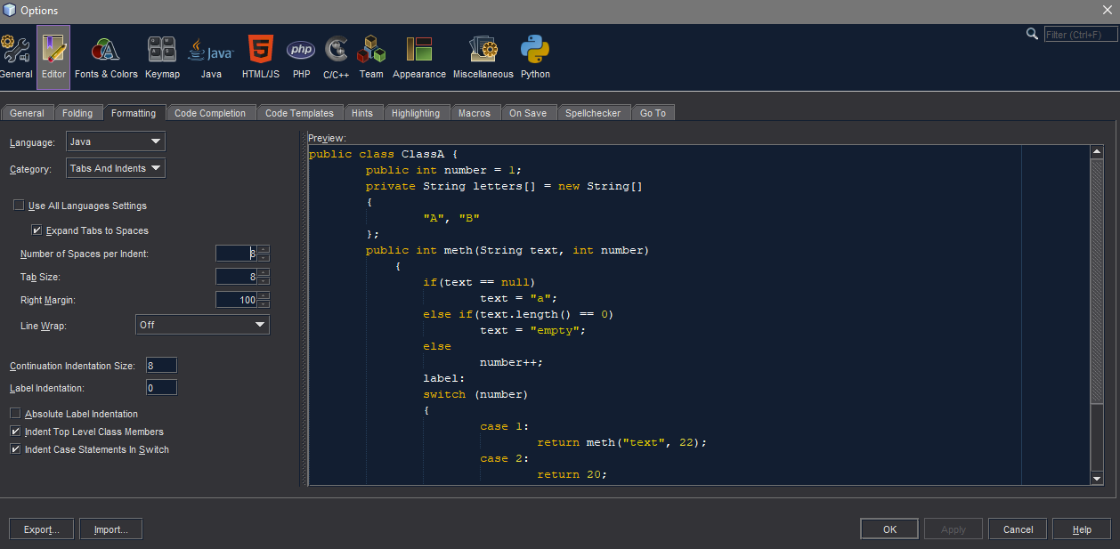
- You must reformat each file to the new rules by opening the file that you create and pressing Ctrl+Shift+F.

